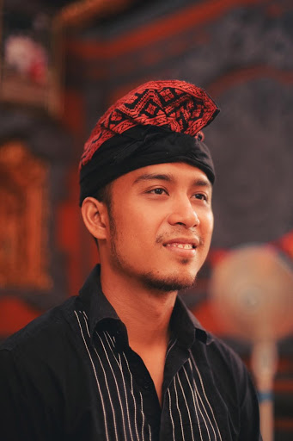

I G.N. Erlangga Bayu R.P

Bachelor of Management Udayana University

*Pursuing* MBA CCE ITB and M.Kom Big Data & E-Business Intelligence Maranatha University

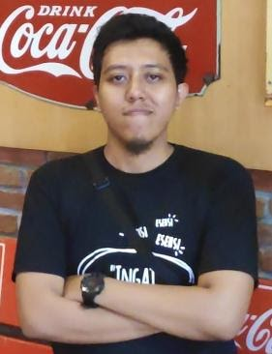

Muhammad Fahmi

Bachelor of Electrical Engineering UGM Yogyakarta

*Pursuing* Master of Ocean Engineering ITB Bandung

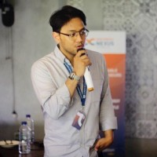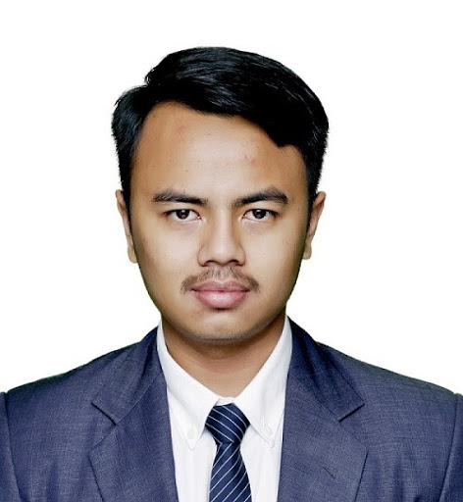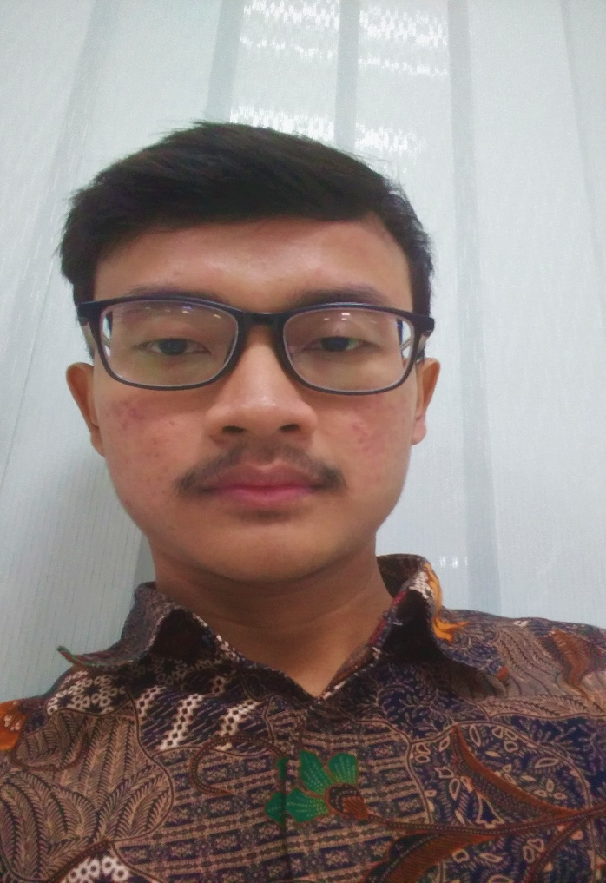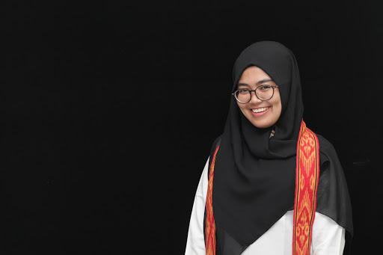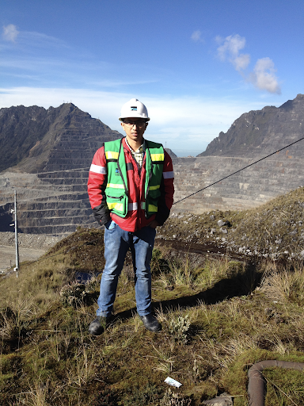

Muhammad Haekal

Bachelor of Electrical Engineering UGM Yogyakarta

*Pursuing* Master of Business Administration ITB

I Made Aditya Suryawidya

Advisor

Bachelor of Geophysics Engineering, ITB Bandung

MBA of Energy

Management, University of Aberdeen, UK

Andhita Tyas

Bachelor of Physical Engineering UGM Yogyakarta

*Pursuing* Master of Mechanical Engineering ITB Bandung

Wahyu Krisna Aji Febriansyah

Diploma of Electronical, Universitas Negeri Jakarta

Cokorda Gde Dwipa Susila

Bachelor of Computer Science BINUS University Jakarta

Magister of Management BINUS University Jakarta

Fadhel Rabbani

Bachelor of Architecture UPI Bandung

*Pursuing* Master of Business Administration ITB

A.A. Ngurah Edy Prayoga

Bachelor of Electronical, Universitas Udayana

Aldi Taher

Bachelor of Computer Maranatha Christian University

Wiji Purwatmo

Bachelor of Electrical Engineering UGM Yogyakarta

*Pursuing* Master of Business Administration ITB

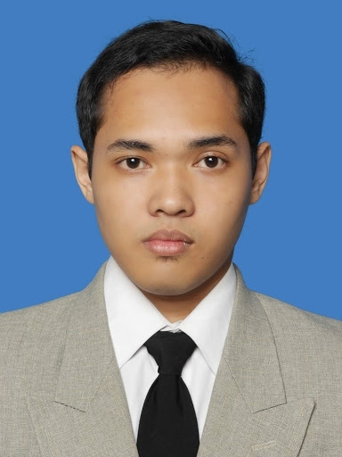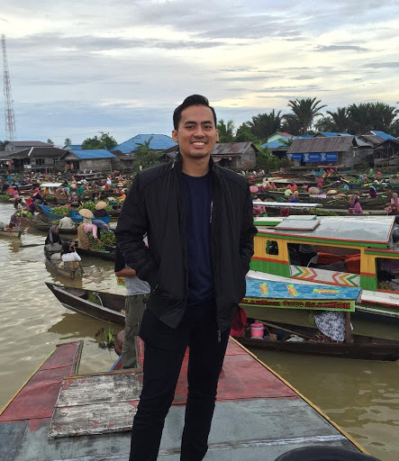

Naufal Riyandi

Bachelor of Physics Padjadjaran University Bandung

*Pursuing* Master of Mechanical Engineering ITB Bandung

A.A. Ngurah Krisna Wisesa

Bachelor of Electronical, STT PLN Jakarta